SPH3U0 Reflection/Transmission of Pulses

1**.**

a. In the box below, draw the pulse as it b. Draw the pulse as it returns

returns after reflecting from a fixed end. after reflecting from a free end.



2.

a. Draw the pulse as it returns after b. Draw the pulse as it returns

reflecting from a fixed end. after reflecting from a free end.

P

*3. The diagram to the right shows a pulse traveling from a “light” string to a “heavy” string. In the box below, draw the reflected and transmitted pulses after the original pulse has reached point P.*

P

*4. The diagram to the right shows a pulse traveling from a “heavy” string to a “light” string. Draw the reflected and transmitted pulses after the original pulse has reached point P.*

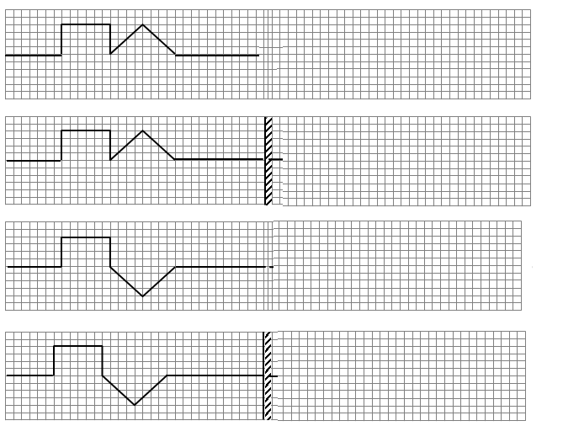5. On the lines below draw the pulses as they would appear after they have completed their reflection from the end. Slanted lines, (//), following the barrier line represent a fixed end. Otherwise the barrier is a “free end.”